Packet Tracer - Compare Layer 2 and Layer 3 Devices (Instructor Version)
Instructor Note: Red font color or gray highlights indicate text that appears in the instructor copy only.

Objectives
Part 1: Compare Layer 2 and Layer 3 Switches
Part 2: Compare a Layer 3 Switch and a Router

Background / Scenario
In this activity, you will use various commands to examine three different switching topologies and compare the similarities and differences between the 2960 and 3650 switches. You will also compare the routing table of a 4321 router with that of a 3650 switch.
Note: Search the internet for more details about the WS-C3650-24PS-L Layer 3 switch and the ISR 4321/K9 router.

Instructions

Compare Layer 2 and Layer 3 Switches

Explore the Physical Workspace.
      - In the Physical Workspace, click the Home City image. Click the Corporate Office image. Click the Main Wiring Closet image.
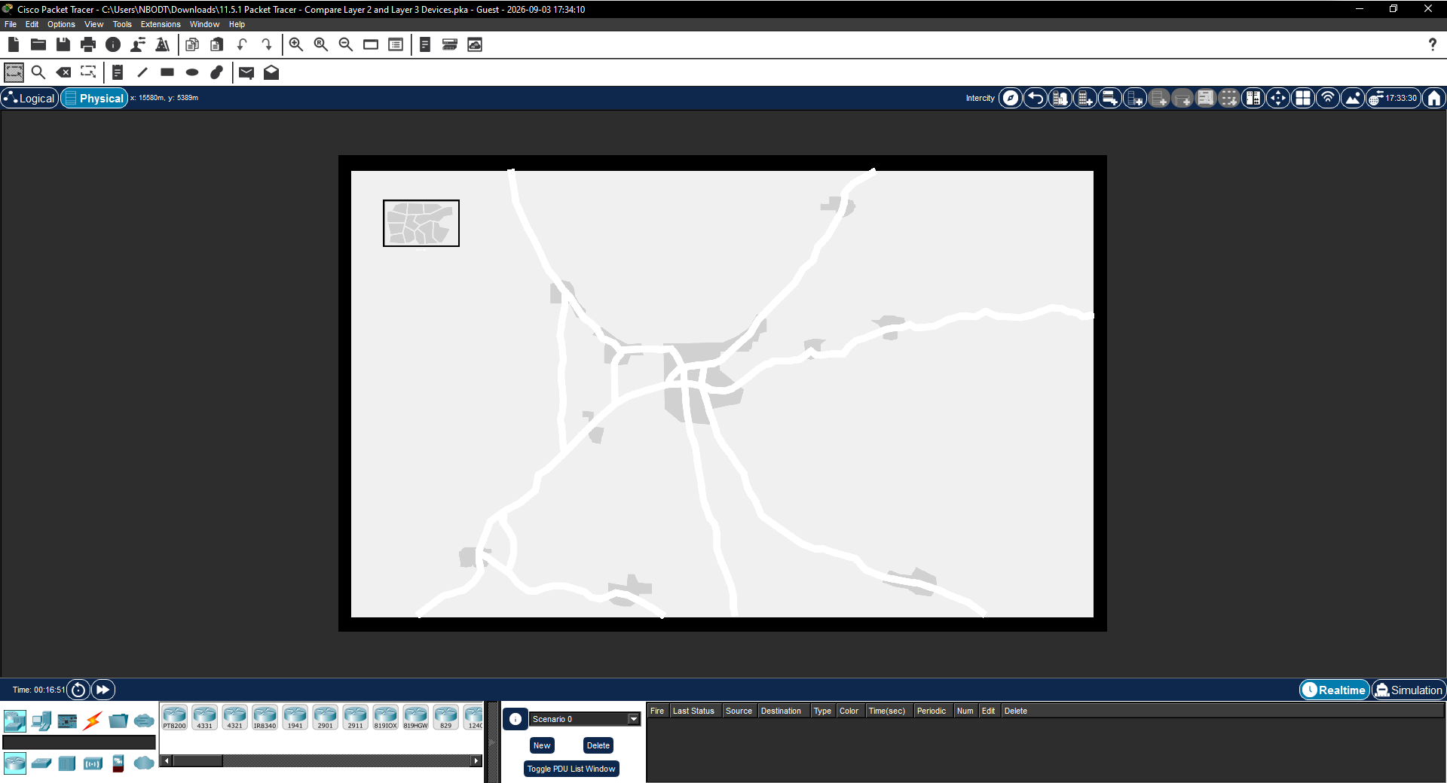
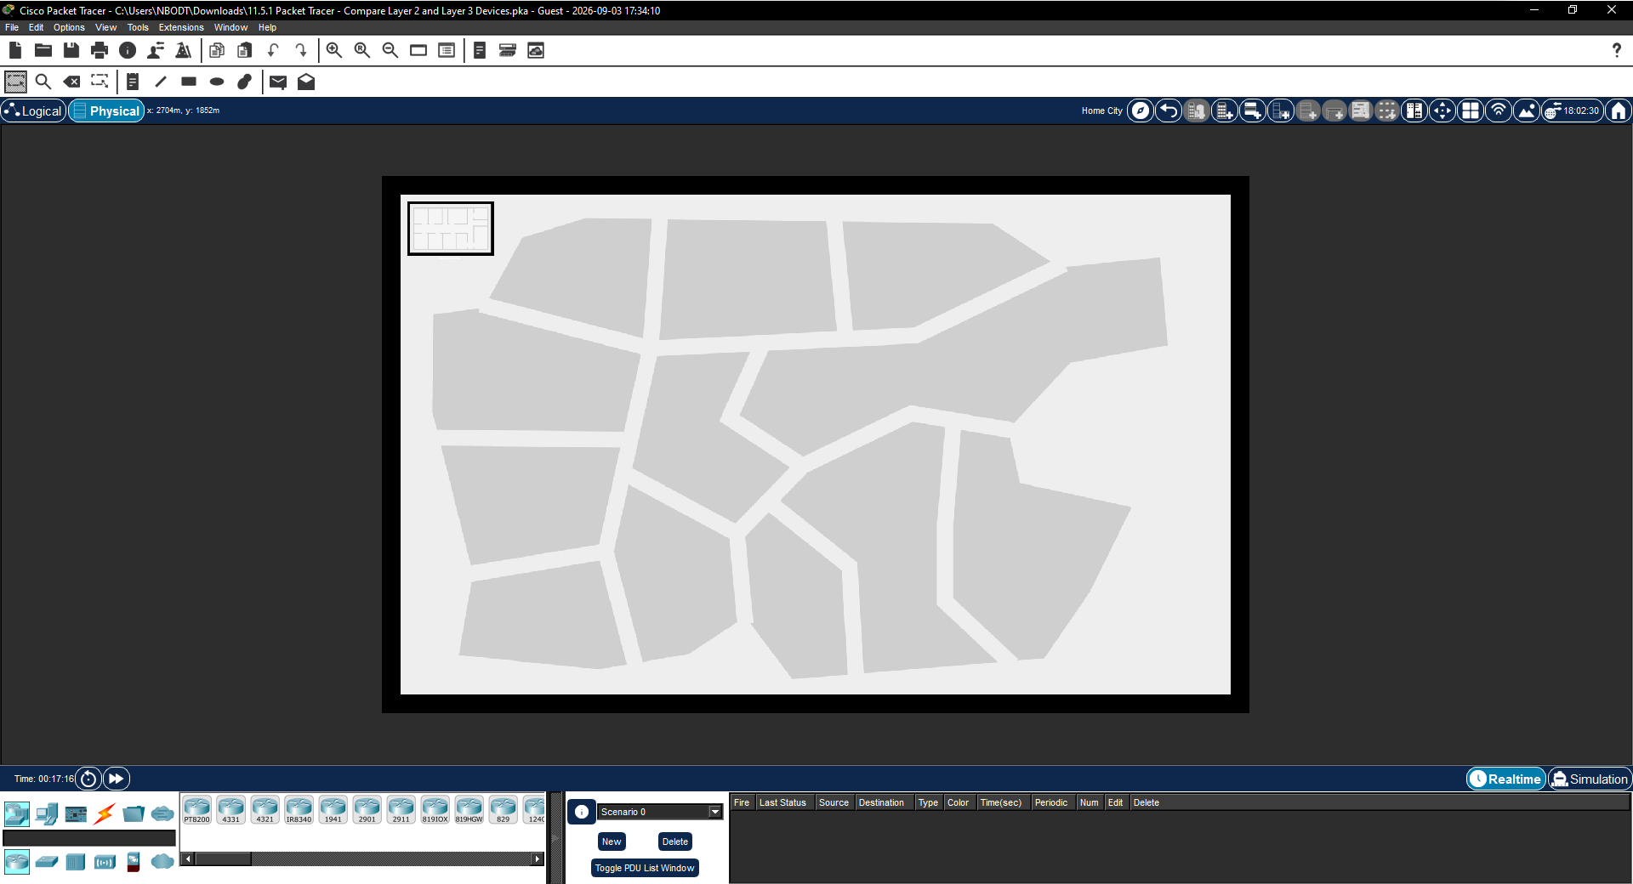
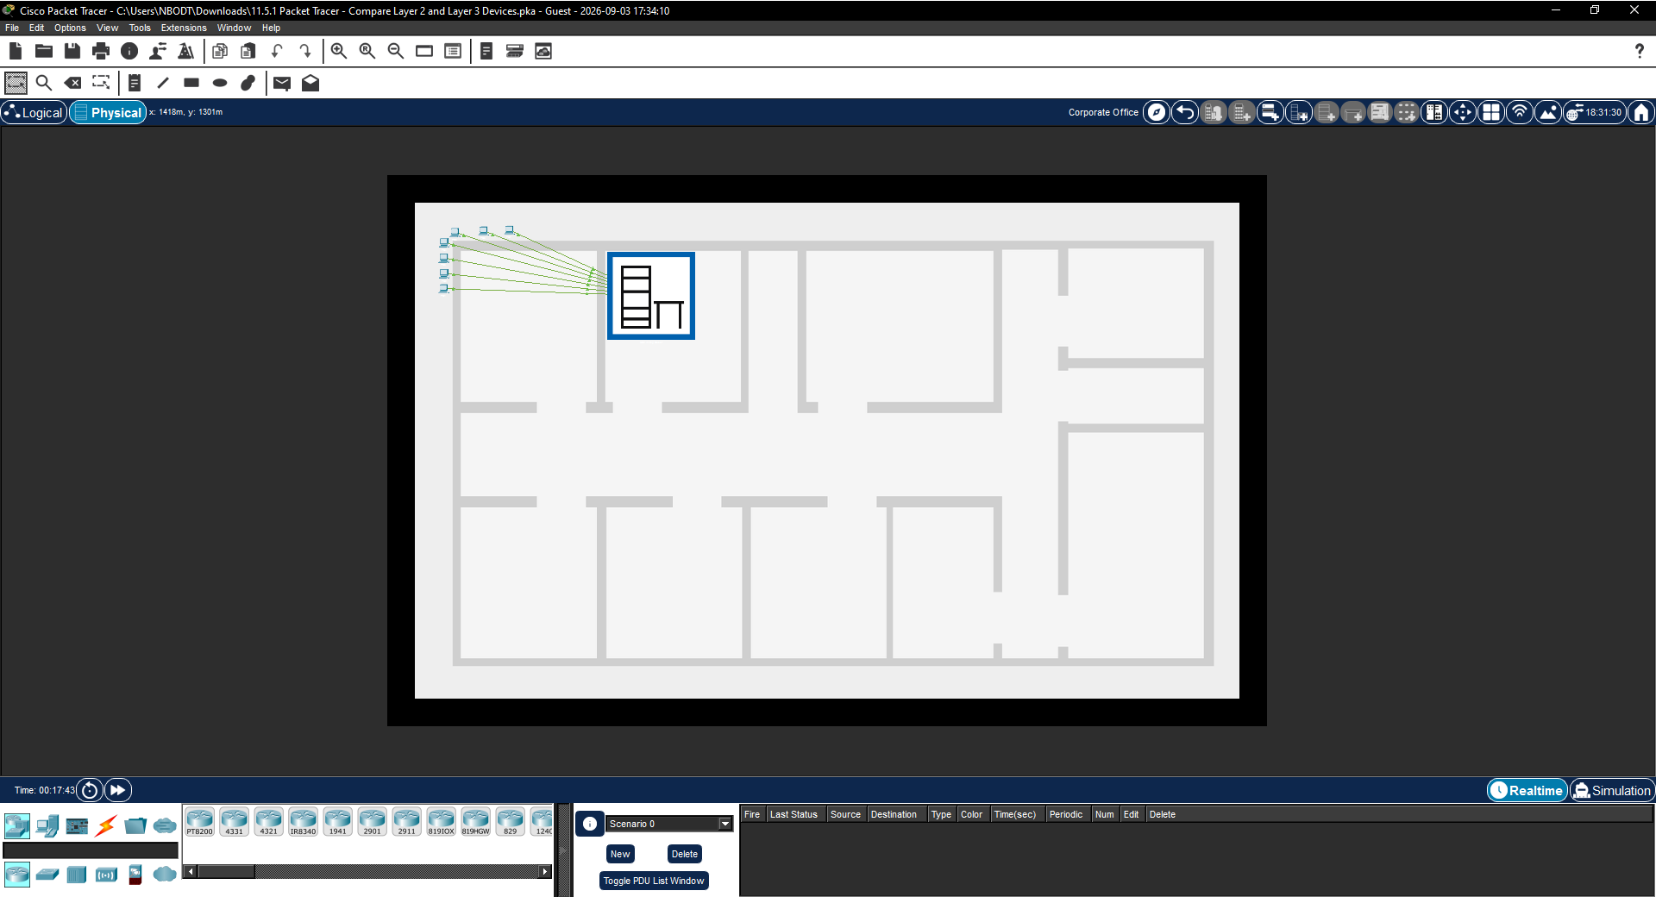

      - In the Rack, locate the devices D1 and ASw-1. Examine the physical aspects of D1 and ASw-1. If you need to examine the devices more closely, click the device and select the Physical tab.
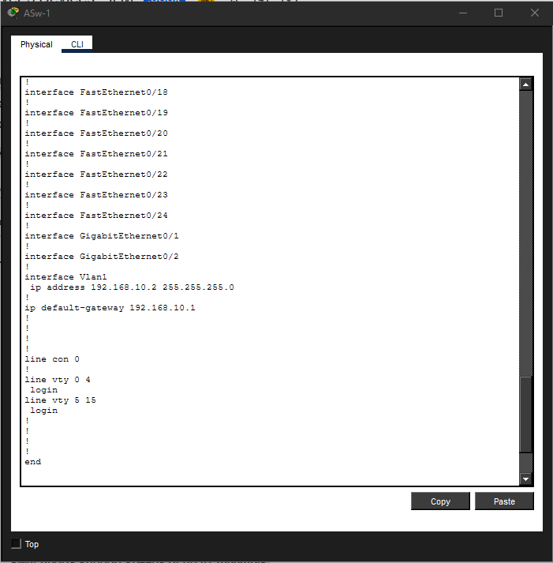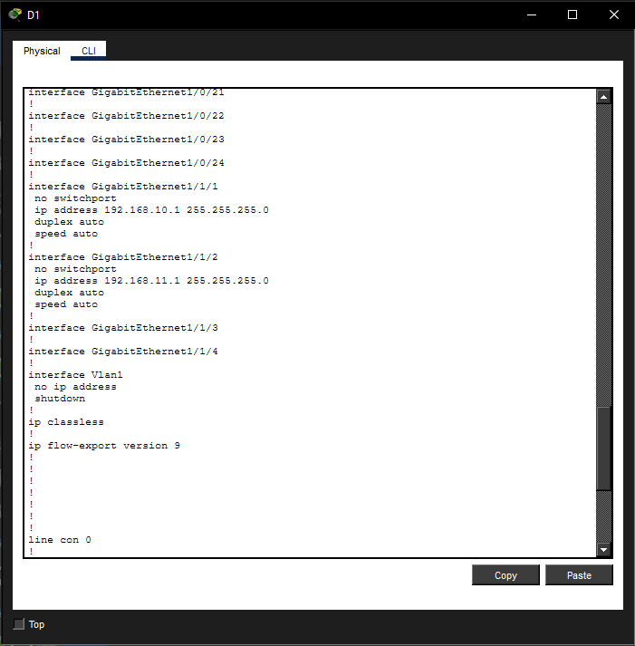

Questions:
Each individual switch has how many physical switchports?pe your answers here.
The 2960 has 26 ports. The 3650 has 24 fixed ports and four modular ports that accept SFP modules.
How many Fast Ethernet and Gigabit Ethernet switchports does each switch have?ype your answehere.
The 2960 has 24 Fast Ethernet and 2 Gigabit Ethernet switchports. The 3650 has 24 fixed and 4 modular Gigabit Ethernet ports.
List the transmission speed of the Fast Ethernet and Gigabit Ethernet switchports on each switch.
The Fast Ethernet switchports support speeds of 10/100mb/s, and the Gigabit Ethernet switchports support speeds of up to 1000mb/s.
Are either of the two switches modular in design?
Yes, the 3650.

In the CLI tab
      - The switchports of a 3650 switch can be configured as Layer 3 interfaces by entering the no switchport command in interface configuration mode. This allows technicians to assign an IP address and subnet mask to the switchport in the same way that they are configured on a router interface.
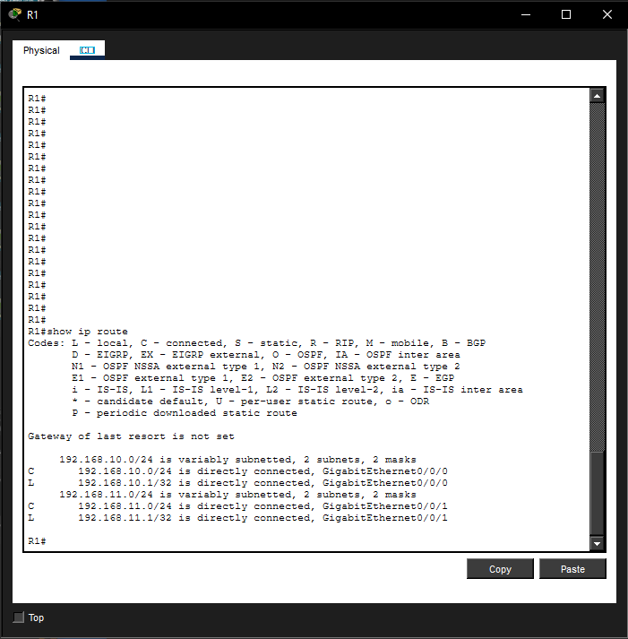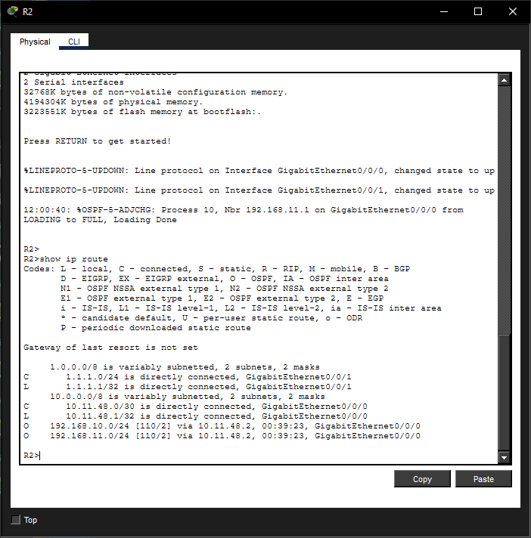

Questions:
What is the difference between a Layer 2 switch and a Layer 3 switch?ype your answers here.
A Layer 2 switch makes forwarding decisions based on L2 (MAC) addresses. Switchports on Layer 3 switches can be configured as interfaces with IP addresses. The switches can also be configured with routing protocols like a router.
What is the difference between a switch’s physical interface and the VLAN interface?ype your answeere.
A switch’s physical interface is used to physically connect end devices to the network. A switched virtual interface (SVI or VLAN) is used to configure the switch with an IP address so that it can be managed remotely.
At which layers do 2960 and 3650 switches operate?pe your answers here.
The 2960 operates at Layer 2, and the 3650 operates at Layers 2 and 3.
      - Navigate to the CLI tab for both devices. Issue the show run command to examine the configurations of the D1 and ASw-1 switches.

Question:
Do you notice any differences between them? here.
Yes, D1's ports are all Gigabit Ethernet, while the 2960 has mostly Fast Ethernet ports and two Gigabit Ethernet ports that are intended for uplinks between switches. In addition, the D1 has different designations for its ports. The D1 uses the stack-module-port format. D1 has switch ports that are configured with the no switchport command and show an IP address and mask configured on the G1/1/1 and G1/1/2 ports. Also, D1 has IP routing enabled with the ip routing command.

      - Try to display the routing table on D1 and ASw-1 using the show ip route command.

Question:
Why do you think the command does not work on ASw-1 but works on D1?
It works on D1 because it functions on Layers 2 and 3, which allows it to function as a Layer 2 switch but at the same time, allows it to route packets and make forwarding decisions based on Layer 3 information (IP addresses) that conventional switches cannot. ASw-1 is a Layer 2 switch and therefore does not have a routing table.

Compare a Layer 3 Switch and a Router
In the past, switches and routers have been separate and distinct devices. The term switch was set aside for hardware devices that function at Layer 2. Routers, on the other hand, are devices that make forwarding decisions based on Layer 3 information. They use routing protocols to share routing information and to communicate with other routers. Layer 3 switches, such as the 3650, can be configured to forward Layer 3 packets. Entering the ip routing command in global configuration mode allows Layer 3 switches to be configured with routing protocols, which gives them some of the capabilities of a router. Although similar in some ways, Layer 3 switches are different from routers in many other aspects.
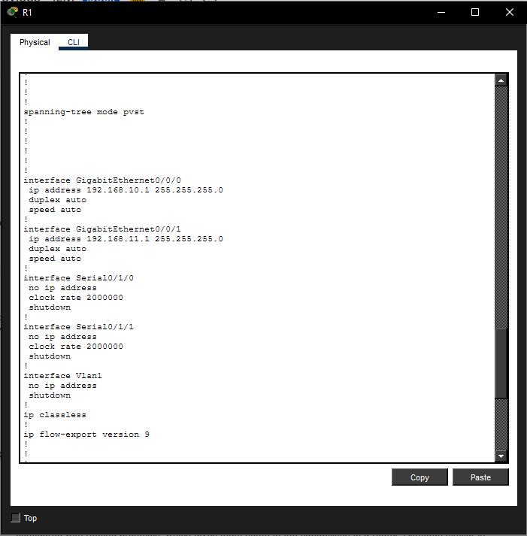
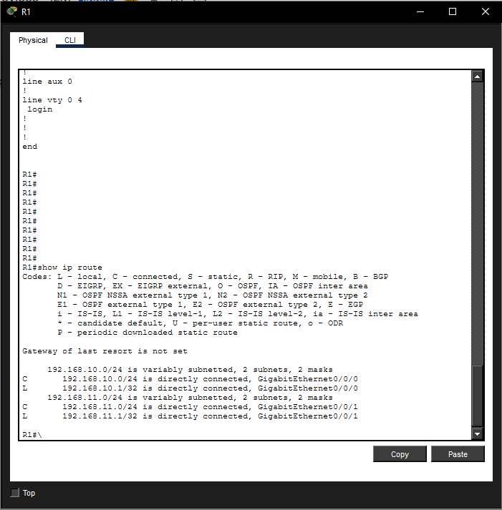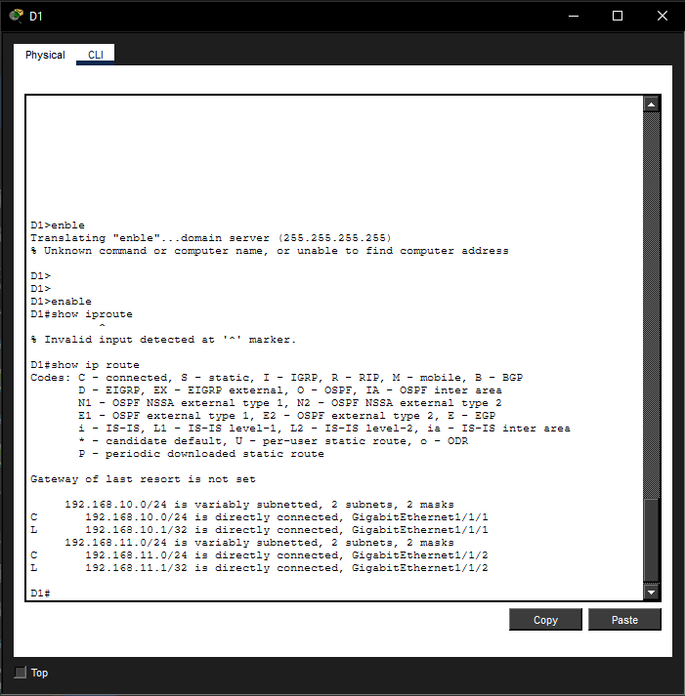

Compare D1 and R1
      - Open the Physical tab on D1 and R1.

Question:
Do you notice any similarities between the two? Do you notice any differences between the two?
They both have a console port, USB ports, and Gigabit Ethernet interfaces. Both R1 and D1 are modular, meaning different interfaces can be added. R1 has Serial and Asynchronous interfaces while D1 only has Ethernet interfaces. D1 can use copper or fiber-based Ethernet depending on the modules that are present and R1 can use various connection types also depending on the modules in use. D1 has many more Gigabit Ethernet ports than R1.
      - In the CLI tab, issue the show run command and examine the configurations of R1 and D1.

Questions:
What differences do you see between the two?
R1 and D1 have the same IP addresses configured on them but on different interfaces.
Which command allows configuration of D1 with an IP address on one of its physical interfaces?
The no switchport command.
      - Use the show ip route command on both devices.

Question:
Do you see any similarities or differences between the two tables?
The codes are the same except the router has an L code for local. This is a link that is configured on the physical interface of R1. The switch routing table does not have this code. Both devices display the same networks in their routing tables.

Compare R2 and D2
      - Now, analyze the routing table of R2 and D2. Click both devices in the Rack. In the CLI tab, issue the show ip route command.
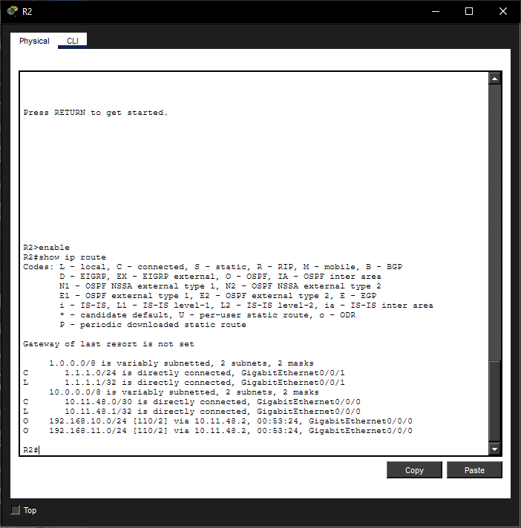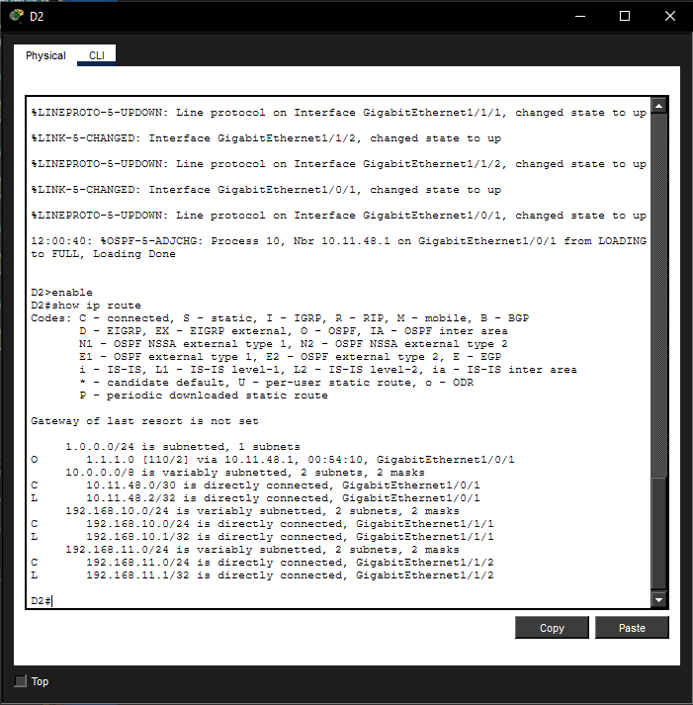

Questions:
What is present now that was not present in the configuration of R1 and D1?
They both have OSPF configured and both are learning networks from one another.
Which network is in the routing table of D2 that was learned from R2
The 1.1.1.0/24 network was learned from R2.
      - Click the Back Level icon (Alt + Left) to leave the Main Wiring Closet. Verify that each topology has full connectivity by completing the following tests:
Ping from PC1 to PC2
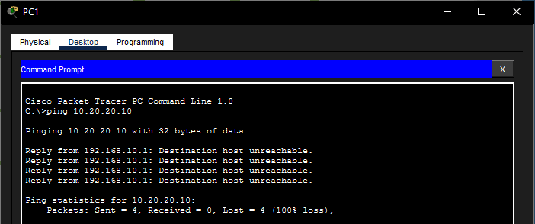

Ping from PC3 to PC4
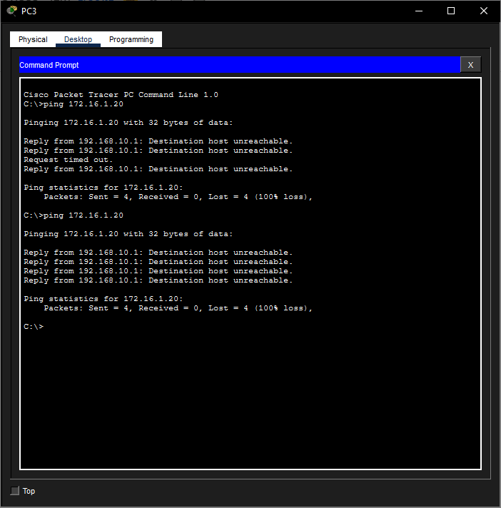
Ping from PC5 to PC6 and PC7
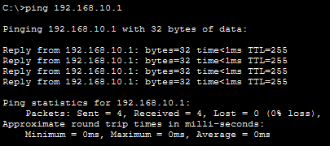
In all three examples, each PC is on a different network.
Note: You may need to move the PCs to see them.

Questions:
Which device is used to provide communication between networks?
Router or multilayer switch.
Why were we able to ping across networks without there being a router?
A multilayer switch can route between networks as long as it is configured with an IP address and has IP routing enabled. IP routing must also be enabled if you plan to run routing protocols such as OSPF on the switch. The no switchport command must be enabled on the interface in order to assign an IP address and subnet mask on the switch’s physical interface.
Bonus question: We say that routers are Layer 3 devices and conventional (non-Layer 3) switches are Layer 2 devices. However, we can assign an IP address to a management (SVI) interface of a Layer 2 switch. How is this possible if switches are Layer 2 devices?
Managed Layer 2 switches, such as the Cisco Catalyst 2960, have an embeded server that can be reached over Layer 3. The server enables Telnet, SSH, or HTTP access to the switch from across the network so that the switch can be remotely managed and configured. It is useful to think of this functionality as separate from the data forwarding function of the switch, which exists at Layer 2.
End of document

